Think Marks

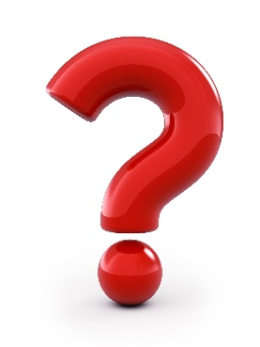
Question
Confused? I wonder? Vocabulary?
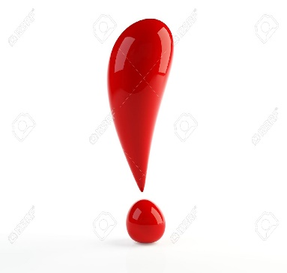
Important
I made a connection! I liked it!
A-ha moment!

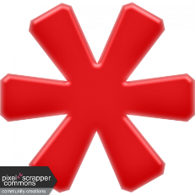
Sharable Moment

